
Checkmate Solution Architecture Document

Project: Checkmate Healthcare Compliance Platform
Version: 1.0
Author: Gundlapalli Muralidhar
Date: 21st May 2025

Approval
Name | Signature | Date
Josh Santiago
Dustin Domerese
Santosh Kumar
Rakesh Reddy
Sai Morigala

1. Executive Summary
This document outlines the architecture for a Checkmate healthcare compliance platform that enables Pharma Representatives, Healthcare Providers (HCPs), and Healthcare Organizations (HCOs) to document and validate financial interactions in real-time. It addresses transparency requirements under the Physician Payments Sunshine Act by integrating with CMS Open Payments and supporting audit-ready workflows. The platform uses Azure AD B2C for identity management with role-based access control across web and mobile applications.
2. Scope
In Scope:
- User registration and authentication using Azure AD B2C
- Role-based service access via web and native mobile apps
- Backend logic via .NET 8 services
- Integration with Dynamics 365, Power Automate, and Azure SQL, Open Payments
Out of Scope:
- In-depth UI design
- Backend infrastructure deployment details
Assumptions:
- All users will be registered through Azure AD B2C
- Role-based access is centrally enforced
- Mobile app supports both Android and iOS

3. Architecture Goals and Constraints
Goals:
- Provide a secure and unified access experience
- Enable role-specific features.
- Maintain scalability with cloud services
- Ensure extensibility for future workflows via Power Automate
Constraints:
- Azure services stack (B2C, SQL, Power Automate) is mandatory
- Login with LinkedIn, Twitter, Google, and Apple accounts must be supported.

4. High-Level Architecture
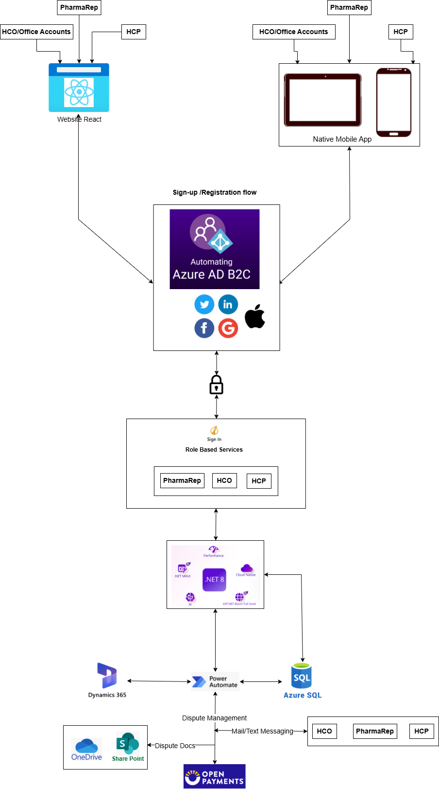

4.1 Users and Channels
- Users: PharmaRep, HCO/Office Accounts, HCP
- Channels:
  - Web (React-based)
  - Native Mobile App (Android/iOS)
4.2 Identity Management
- Azure AD B2C handles:
  - Sign-up and login flows
  - Identity federation with external providers (Google, Facebook, LinkedIn, Twitter, Apple) TBD
4.3 Middleware
- .NET 8 based APIs services as backend
- Implements role-based service orchestration
4.4 Integration Layer
- Power Automate handles workflow automations
- Dynamics 365 manages CRM and entity data
- Azure SQL serves as the transactional data store
- Open Payments for dispute management

5. Component Breakdown
5.1 Frontend:
Component | Technology
Web UI | React
Mobile App | Native (iOS & Android)
5.2 Authentication
Feature | Details
Provider | Azure AD B2C
Identity | Google, Facebook, LinkedIn, Twitter, Apple TBD
Registration & Login Flow | Unified across all devices
5.3 Middleware
Component | Technology
API Services | .NET 8
Features | Role-based authorization, API routing
5.4 Backend Systems
Component | Technology
Workflow Engine | Power Automate
CRM | Dynamics 365
Database | Azure SQL

6. Data Architecture
- Authentication Data: Stored in Azure AD B2C
- Transactional Data: Stored in Azure SQL
- Entity Data (Contacts, Activities, etc.): Stored and managed in Dynamics 365
- Integration Data Flow: Orchestrated via Power Automate workflows

7. Security Architecture
- Identity Management: Azure AD B2C
- Authentication: OAuth2 / OpenID Connect
- Authorization: Role-based access control (RBAC)
- Data Protection: SSL for data in transit, Azure-managed encryption at rest
- Audit Logging: Enabled via Azure AD and application telemetry

8. Deployment Architecture
- Hosting: Azure App Services for .NET APIs
- Storage: Azure SQL
- Mobile App Distribution: App Store, Google Play

9. Quality Attributes
Attribute | Implementation Strategy
Scalability | Cloud deployment with autoscaling
Reliability | Azure services with SLA guarantees
Maintainability | Modular architecture using .NET services
Security | Azure AD B2C with RBAC
Performance | Optimized endpoints and caching strategies
Testing | End to end testing, Functional Testing, integration testing, Unit Testing

10. Risks and Mitigations
Risk | Impact | Mitigation Strategy
Dependency on Azure AD B2C | High | Evaluate backup IdP
Third-party identity outages | Medium | Offer default Azure fallback
Mobile app platform discrepancies | Medium | Implement unified APIs
Open payments | High | Testing with sandbox

11. Appendices
A. Glossary:
- PharmaRep: Pharmaceutical sales representative
- HCP: Healthcare Provider
- HCO: Healthcare Organization
- IsP: Identity Provider
B. References:
- Azure AD B2C documentation
- .NET 8 API guidelines
- Dynamics 365 connector for Power Automate
- Open Payment documentation

